EXP NO 11 Implement an application that writes data to the SD card

AIM:
To develop an Android application using Android Studio that allows users to enter data and store it in the device’s SD card (external storage).

ALGORITHM:
- Input:
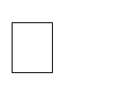
The user enters text data in the application.

The user clicks a button to save the data into the SD card.
- Steps for Implementation in Android Studio:

  - Create a New Android Project: Open Android Studio


Create a new project with an Empty Activity Choose Java or Kotlin as the programming language
  - Design the User Interface:

Add the following components in the layout:
    - EditText → to enter data
    - Button → to save data
    - TextView (optional) → to display status messages
  - Add Permissions in Manifest File:

Declare permission to write to external storage

For modern Android versions, also handle runtime permissions

  - Handle Runtime Permissions: Check if permission is granted


If not, request permission from the user at runtime Proceed only after permission is granted

  - Check External Storage Availability: Ensure that:
    - SD card is available
    - SD card is writable
  - Create File in SD Card:

Define a file name (e.g., mydata.txt)


Select appropriate directory:
    - App-specific folder (recommended)
    - Or public directory




  - Write Data to SD Card: Read input from EditText Open file output stream Write the data into the file close the stream

  - Display Output to User: Show confirmation message:
    - “Data saved successfully”
    - Or error message if something fails

  - Handle Exceptions: Manage:
    - IOException
    - Permission denial
    - Storage unavailability
- Testing the Application:


Run the app on a real device/emulator Enter sample text

Click Save button

Verify file using file manager in external storage
- Observations:


Data is stored successfully in the SD card Runtime permission handling is essential

External storage path must be handled carefully in newer Android versions

OUTPUT:


User enters text → Clicks Save Message displayed:
Data saved successfully to SD card

File mydata.txt created in external storage containing user input

CODE:
ACTIVITY_MAIN.XML
<?xml version="1.0" encoding="utf-8"?>
<LinearLayout xmlns:android="http://schemas.android.com/apk/res/android" android:orientation="vertical"
android:padding="20dp" android:layout_width="match_parent" android:layout_height="match_parent">

<EditText android:id="@+id/inputText" android:hint="Enter text to save"
android:layout_width="match_parent" android:layout_height="wrap_content"/>

<Button
android:id="@+id/saveBtn" android:text="Save to Storage" android:layout_width="match_parent" android:layout_height="wrap_content"/>

<TextView android:id="@+id/status" android:text=""
android:layout_marginTop="20dp" android:layout_width="wrap_content" android:layout_height="wrap_content"/>

</LinearLayout>

OUTPUT:

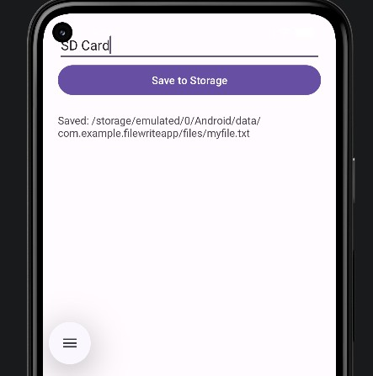

RESULT:
An Android application is successfully developed using Android Studio to write data to the SD card with proper permission handling and storage management.

